App in a Day

Hands-on Lab Step-by-Step

May 2020

Contents

Complete Solution 1

Task 1: Create a new environment 1

Task 2: Import the solution 2

Task 4: Update flow connectors 7

# Complete Solution

Follow the steps below to see the complete solution without completing the modules

## Task 1: Create a new environment

1. Open a new browser tab, navigate to [Power Apps admin portal](https://admin.powerplatform.microsoft.com/) select **Environments** and click **New Environment**.

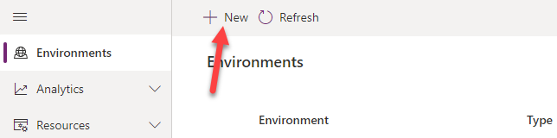

1. Provide an **Environment Name**, select **Trial** for **Type**, select **Region**, select **Yes**, for **Create** a database, and click **Next**.

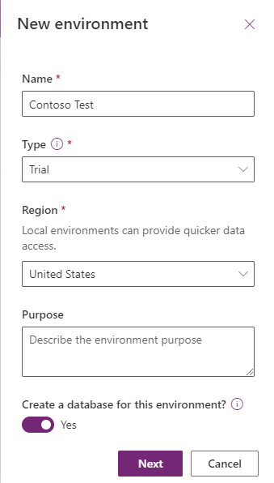

1. Select **Language,** select **Currency**, select **Yes** for **Deploy sample apps** **and data** and then click **Save**.

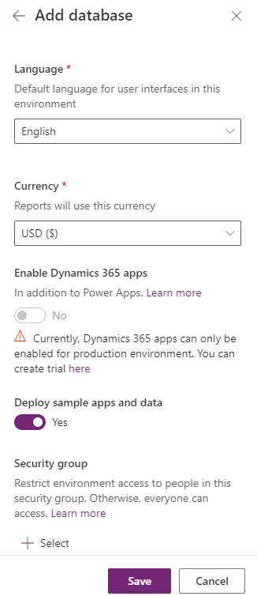

1. Wait for the environment to be created.

## Task 2: Import the solution

In this task, you will import the completed module 3 solution.

1. Navigate to [Power Apps maker portal](https://make.powerapps.com/)
2. Make sure you are in the **Contoso Test** Environment you created.
3. Select **Solutions.**

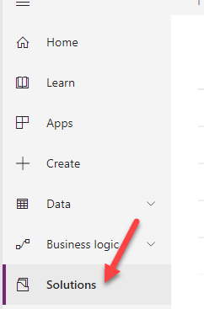

1. Click **Import**.

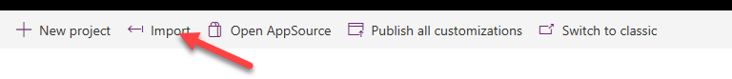

1. Click **Browse**.

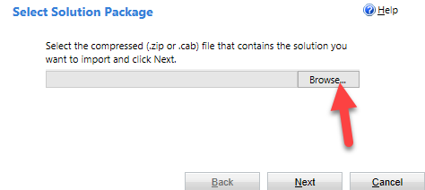

1. Select the **Module 4 Completed Solution** zip file located in Module 4 Complete Solution folder and click **Open**.

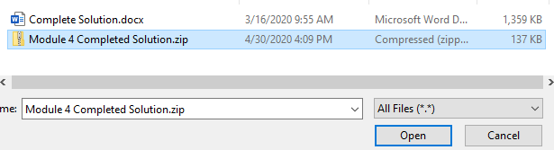

1. Click **Next**.

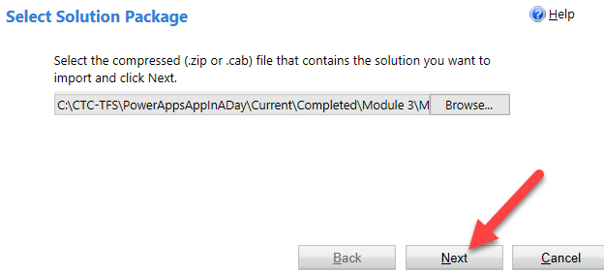

1. Click **Next**.
2. Click **Import**.

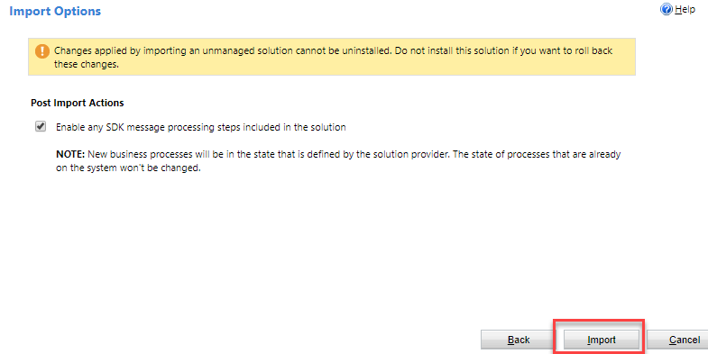

1. Wait for the solution import to complete and click Close.

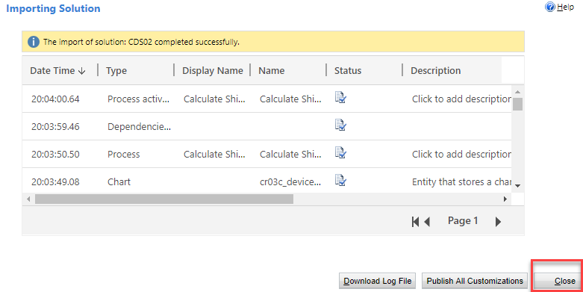

1. Select **Apps**, click on the … button of the application you imported and click **Play**.

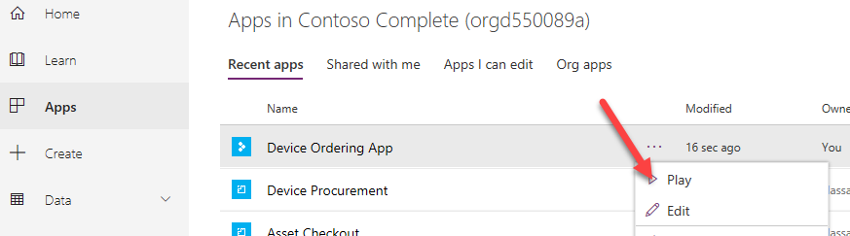

1. Click **Allow**.

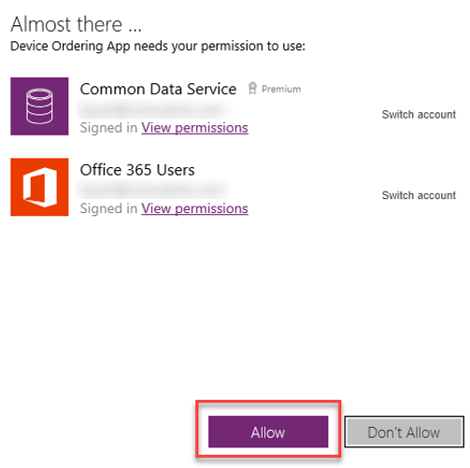

1. Select few devices and click **Compare**.

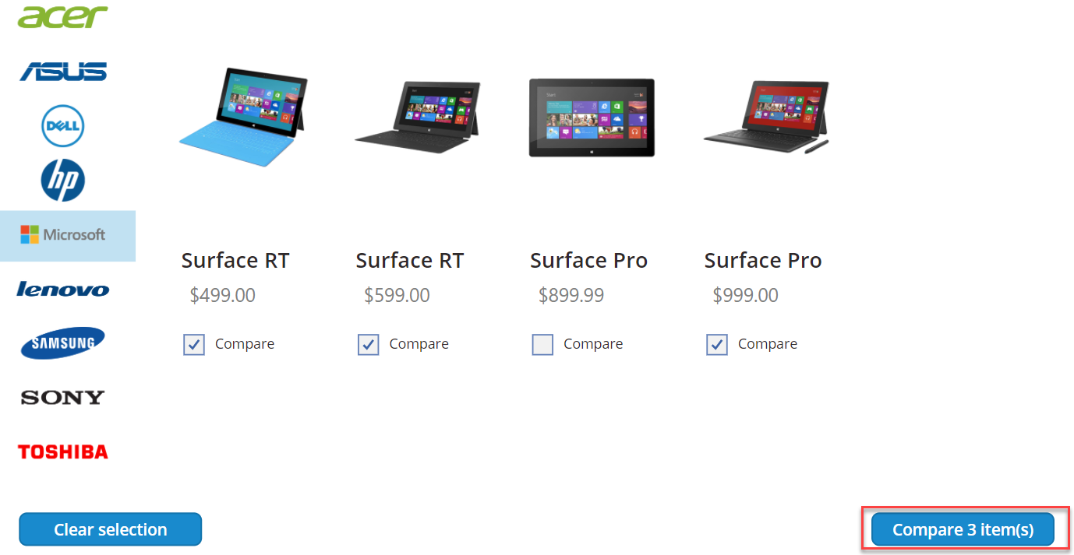

1. Select one of the devices and click **Submit**.

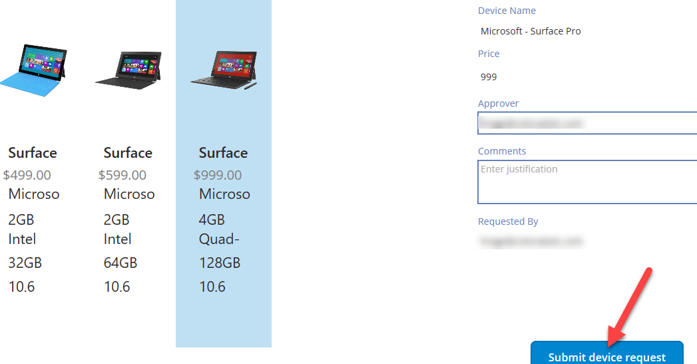

1. Click **OK**.
2. Close the application by simply closing the browser tab.
3. Select **Apps** and start the **Device Procurement** application

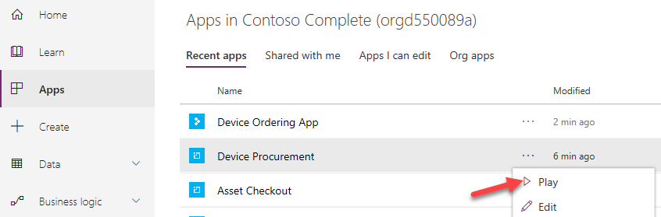

1. Click to open the record you created in the last task.

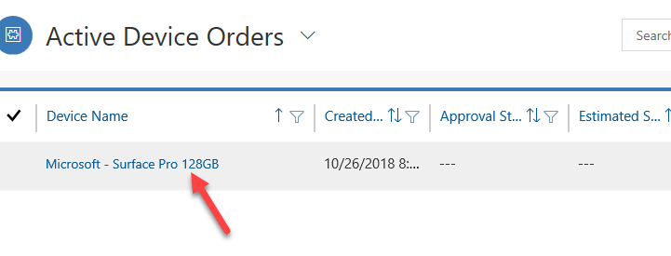

1. The record should open.

## Task 4: Update flow connectors

In this task, you will update the flow connectors.

1. Navigate to [Power Apps maker portal](https://make.powerapps.com/) and make sure you are in the correct environment.
2. Select **Solutions** and click to open the solution you imported.

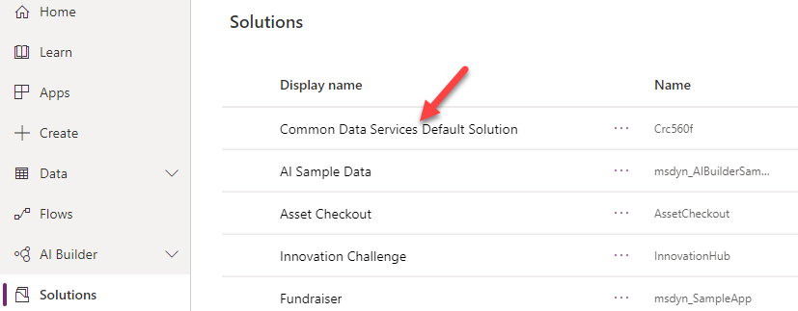

1. Locate the **New device approval request** flow, click on the **….** button, and select **Details**.

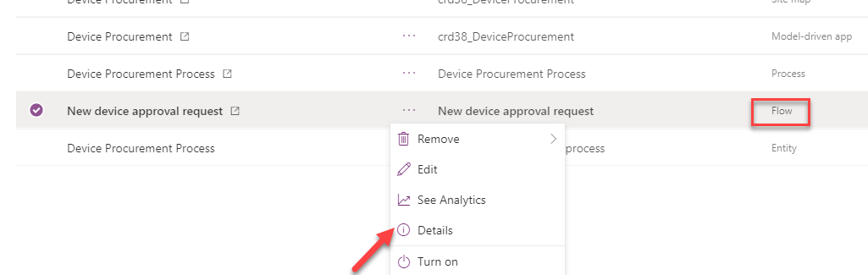

1. Click **Edit**.

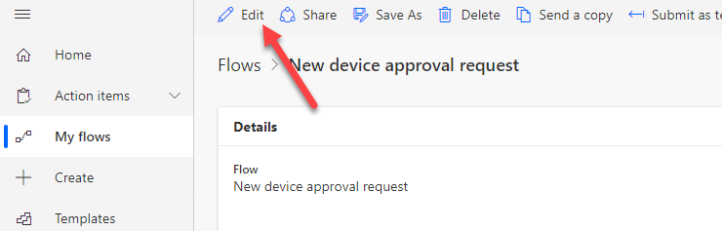

1. Click to expand the trigger step.

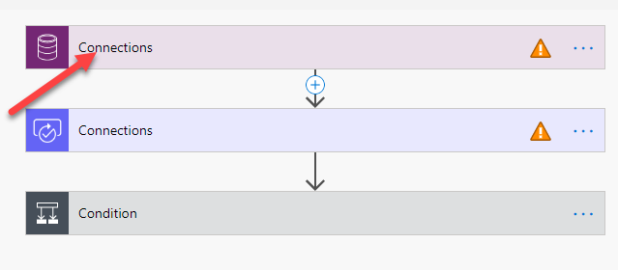

1. Click **Add new connection**.

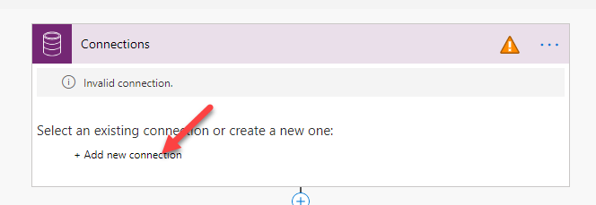

1. The connection should update. Click to expand the approval step.

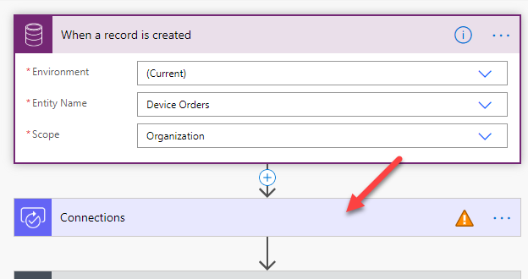

1. Click **Add new connection.**

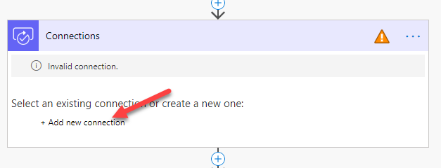

1. The connection should get updated. Click to expand the condition step.

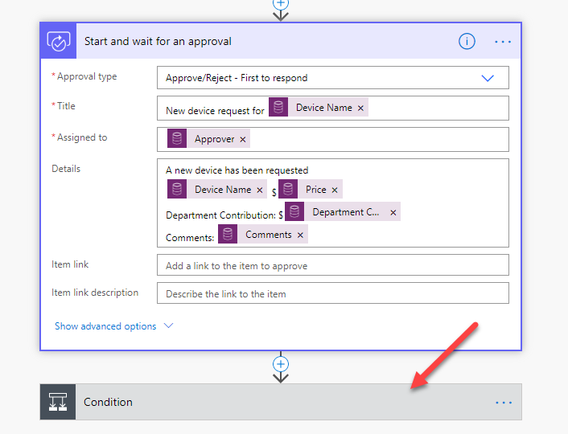

1. Expand the first step of each path and select the existing connection.

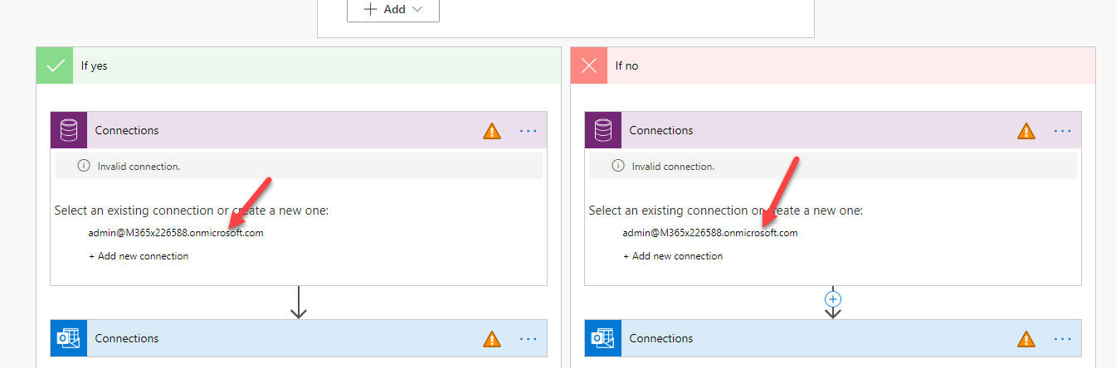

1. Expand one of the send email steps.
2. Click **Add new connection**.

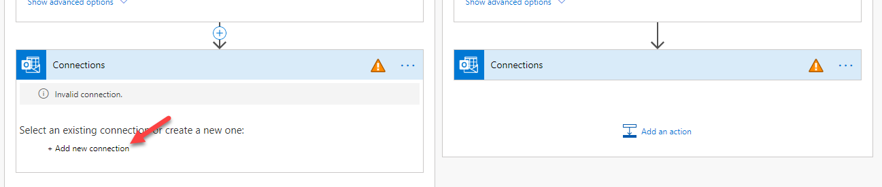

1. Expand the second send email step and select the existing connection.

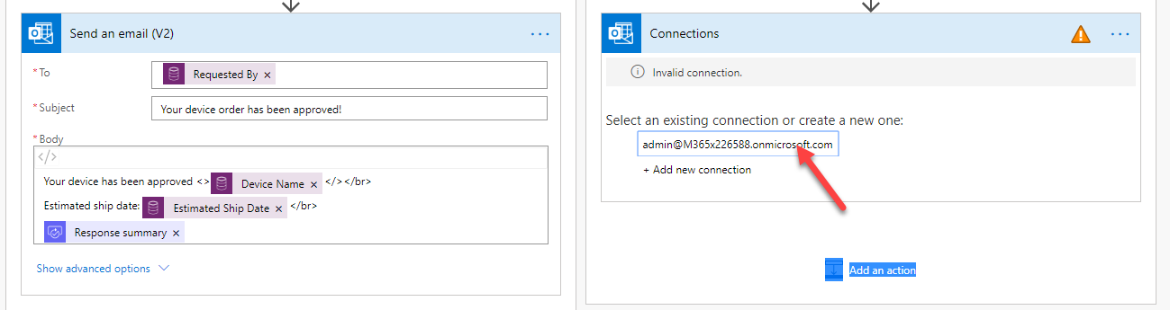

1. Click Save to save your changes.